User Data Management in Scriptoria

Introduction
In April 2023, Google Play announced the new account deletion requirements and added new Data deletion questions within your Data safety form. See Understanding Google Play’s app account deletion requirements for more details.

In the App Builders, on the Data & Analytics ➢ User Accounts ➢ Data Deletion configuration page, you can specify the Data Deletion URLs that will be included in the data-safety.csv, which can be imported into Google Play to answer the questions. If you are using Scriptoria, leave these fields blank and Scriptoria will provide pages for the end user to submit data deletion requests.

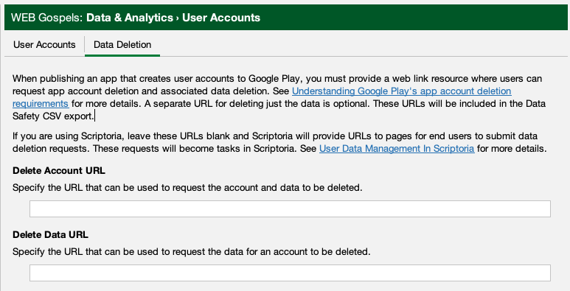

Scriptoria Builds Provide URLs
During a build of an Android App being publishing to Google Play, if the project is using the User Accounts feature and the Delete Account URL field is blank, then Scriptoria will populate both of the URLs with links to pages in Scriptoria to allow the end user to submit data deletion requests. These URLs will be included the the Data Safety CSV export created during the build.

Scriptoria Data Management Form
The Scriptoria user data management page contains a form that prompts the user for their email address and the type of deletion, either “Delete my data” or “Delete my account and all assocated data”. It also describes the items that will removed. It uses a verification code sent to the email address specified to authenicate the person requesting the page.

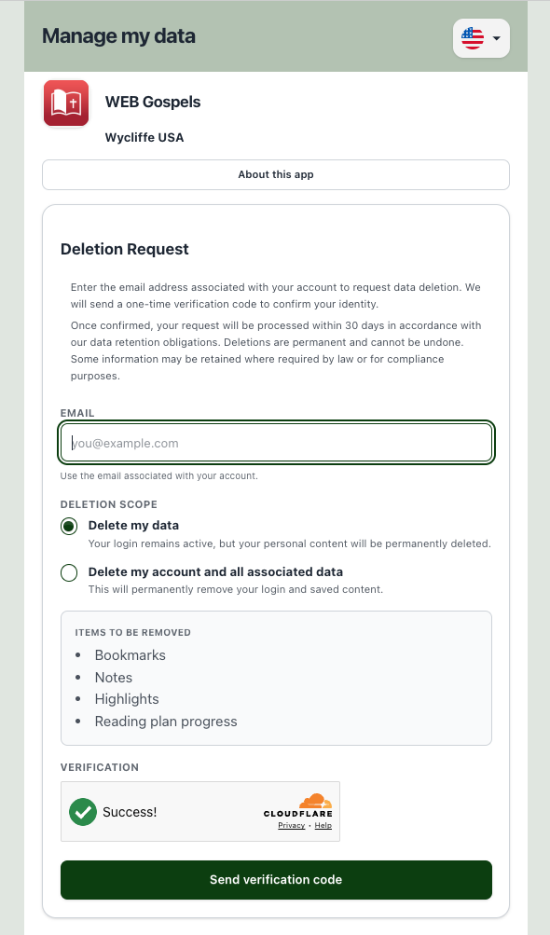

Localization
The page has been localized into all of the languages used in Google Play Listings. There is language selector at the top-right of the page populated with the languages you have provided in the Publishing ➢ App Store ➢ Google Play Listing configuration page in the App Builder.

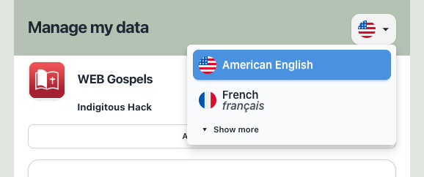
If the user chooses Show more on the language selector, then they can select another language from the complete list of available localizations, but the information in About this app will not be available.\

Verification Code
Once the user and entered their email address and select the type of deletion, they click the Send verification code button. They will receive an email with the code to use.

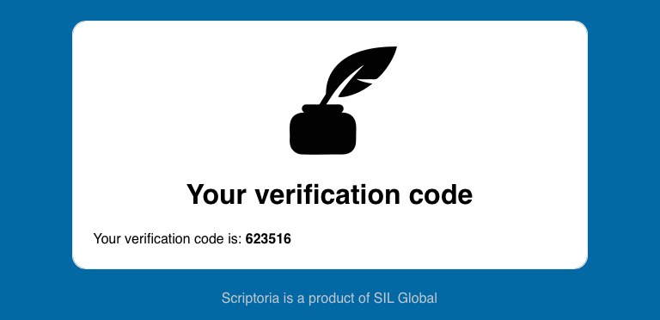
After the receive the verification code, they will enter the code in the confirmation page.
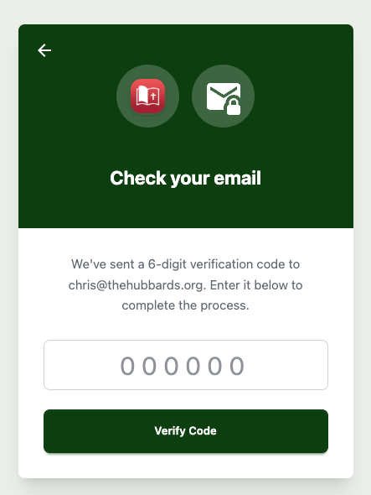
When the enter the verification code and click the Verify Code button, they will will receive a confirmation of the submission of their request.

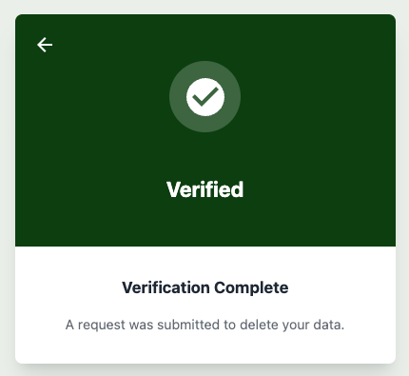

Scriptoria Delete Data Task
After the end user successfully submits the request using the Data Management Form, a new Delete Data task is assigned to the owner of the project.



The Delete Data tasks contains field for email of the User requesting the task, the Console URL of the service holding the information (in this case Firebase), and instructions for performing the task based on whether it is a Delete Account or Delete Data request. There is an option to Transfer to Admin if the owner doesn’t have access to the Firebase account.
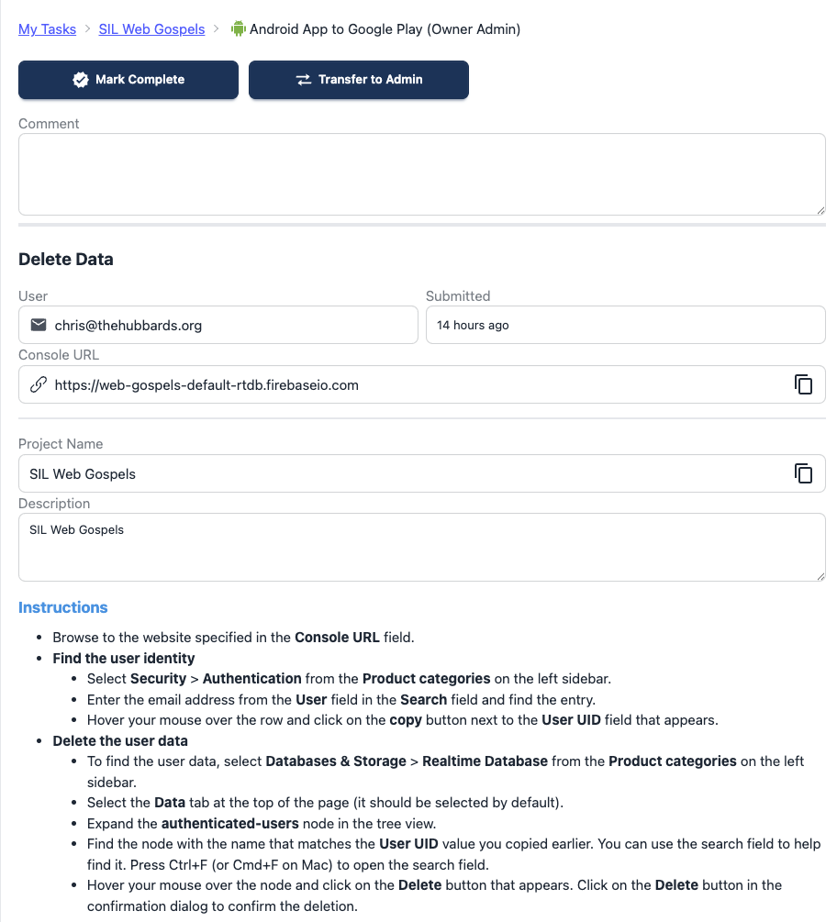
After the instructions have been completed, click the Mark Complete button and the task will be removed from the Scriptoria user. No email is sent the the user requesting the data deletion.

